#include <iostream>

using namespace std;

class student

{

        char name[20];

        unsigned int id;

        double score;

public:

        void input()

        {

                cout << "name? ";

                cin >> name;

                cout << "id?";

                cin >> id;

                cout << "score? ";

                cin >> score;

        }

        void output()

        {

                cout << "name: " << name << "\tid: " << id << "\tscore: " <<score << endl;

        }

};

int main()

{

        student s;

        s.input();

        s.output();

        system("pause");

}

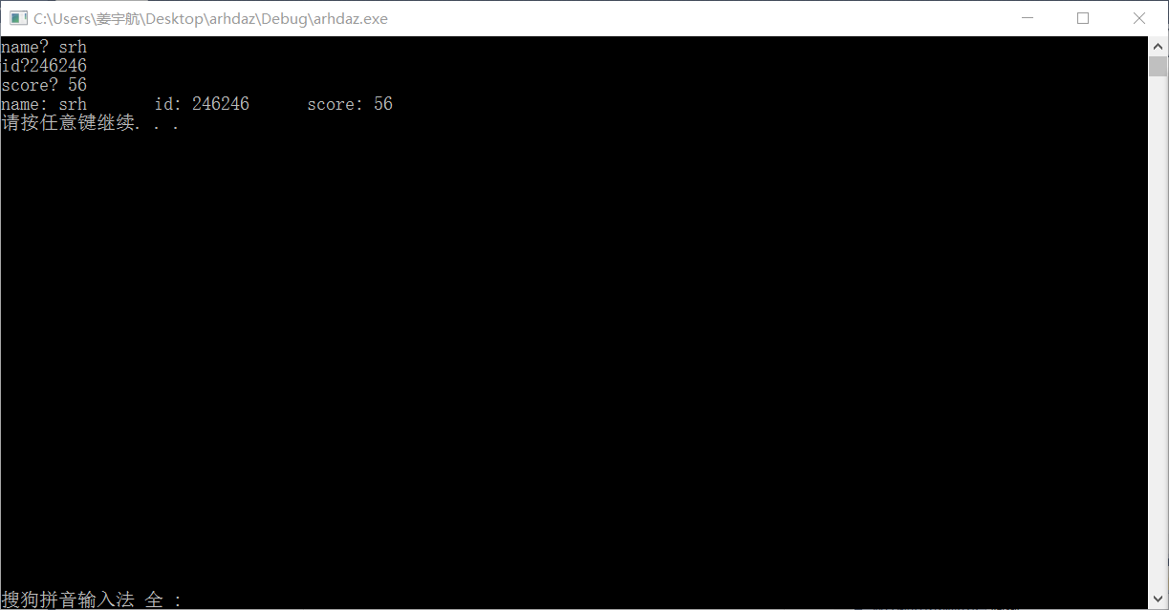

#include<iostream>

usingnamespacestd;

classBook

{public:

voiddisplay();

voidborrow();

voidrestore();

charbookname[100];

doubleprice;

intnumber;

};

voidBook::display()

{cout<<"bookname:"<<bookname<<"\nprice:"<<price<<"\nnumber:"<<number<<endl;}

voidBook::borrow()

{number-=1;

cout<<"number:"<<number<<endl;

}

voidBook::restore()

{number+=1;

cout<<"number:"<<number<<endl;

}

intmain()

{inti;

Bookb;

cout<<"please input the bookname:";

cin>>b.bookname;

cout<<"please input the price:";

cin>>b.price;

cout<<"please input the number:";

cin>>b.number;

for(intx=0;x<10;x++)

{cout<<"\nwhat do you want to do?"<<"\ndisplay--1  borrow--2  restore--3"<<endl;

cin>>i;

switch(int(i))

{case1:b.display();break;

case2:b.borrow();break;

case3:b.restore();break;

}

}

}

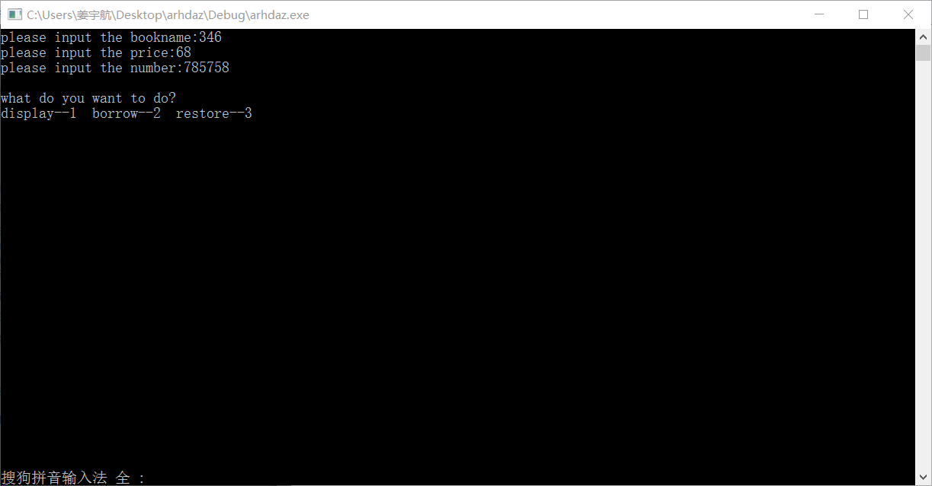

#include <iostream>

using namespace std;

class student

{

        double score;

        static double total;

        static double count;

public:

        void scoretotalcount(double s)

        {

                score = s;

                total = total + score;

                count++;

        }

        static double sum()

        {

                return total;

        }

        static double average()

        {

                return total/count;

        }

};

double student::total = 0;

double student::count = 0;

int main()

{

        int i, n; double s;

        cout << "学生人数：";

        cin >> n;

        student a;

        for (i = 1; i <= n; i++)

        {

                cout << "第" << i << "个学生的分数：";

                cin >> s;

                a.scoretotalcount(s);

        }

        cout << "总分：" << student::sum() << endl;

        cout << "平均分：" << student::average() << endl;

}

